View and apply recommendations in Google Ads

Earlier in this course, a video introduced you to Google Ads and the Recommendations page for campaigns. If you need a refresher, you can replay the Introduction to Google Ads video.

To recap, there is an optimization score on the Recommendations page. The closer the score is to 100%, the better your account is optimized to perform well. To help you improve the optimization score of your advertising, you can review the recommendations and predicted impacts on the Recommendations page and potentially apply one or more of them to your campaigns.

This reading describes the types of recommendations provided by Google Ads and how to apply them to campaigns.

***Note:*** *Since recommendations are tailored to specific types of campaigns, you might not encounter a certain type of recommendation if you’re not running a related campaign. Furthermore, recommendations are based on Google-wide trends paired with your account’s past performance and campaign settings. If your account is brand new or if your ads just started to run, you might not see recommendations right away.*

**Categories of recommendations**

There are five categories of recommendations. Each type is described below. For a more complete view of all available recommendations, consult the resources listed at the end of this reading.

**Ads and Extensions**

Recommendations for ads help maximize performance, such as an ad’s click-through-rate (CTR). Creating a responsive search ad is an example of an ad recommendation. Adding image or location extensions are examples of extension recommendations. Extensions allow advertisers to add additional elements to complement text in ads. For example, when an image extension appears on a search results page, potential customers are shown headlines, descriptions, and a URL along with the actual image. When a location extension appears on a search results page, your address or a map to your location is shown. Image and location extensions can help improve the CTR for ads.

**Keywords and targeting**

Keyword recommendations include actions like pausing poorly performing keywords, removing duplicate keywords, or adding new keywords. Examples of targeting recommendations are displaying all available products instead of just some products, or reaching new customers by showing ads to additional users.

**Bidding and budgets**

Bidding recommendations can help you land on the right bid strategy to meet your business goals. Budget recommendations can help you maximize the best use of your budget. Examples of these include adjusting return on ad spend (ROAS) targets, moving to an automated bid strategy, or adjusting budgets in campaigns that are set to maximize conversions.

**Repairs**

Repair recommendations identify problems with campaign settings or management so you can fix them.

**Automated campaigns**

Automated campaign recommendations help you maximize performance by switching over to fully automated campaigns, such as Smart Shopping or Smart Display campaigns.

**How to manage recommendations**

Most advertisers don’t apply *every* recommendation that Google Ads presents on the Recommendations page. If you did apply every recommendation, you would be better served by an automated process. So why do you need to review recommendations? While some recommendations can be applied immediately, others won’t actually make sense for your campaign, or will require additional planning or testing to be implemented successfully. One approach to managing your recommendations is to review each recommendation presented and decide whether you will:

* Immediately apply it
* Plan to apply it later
* Dismiss it (for now)

**Immediately apply**

Most recommendations are displayed with an Apply button. However, the Apply button is usually reserved for immediately implementing recommendations that are maintenance-like by nature. This includes recommendations classified as repairs, but can also include modifications to ad copy or suggestions like switching to an optimized ad rotation to automatically show your best ads at auction time. For recommendations that you would normally choose to apply immediately, you can consider enabling the Auto-apply setting to save you time.

Below is an example of a recommendation card with a suggestion to switch over to optimized ad rotation. This is a recommendation that you could immediately apply.

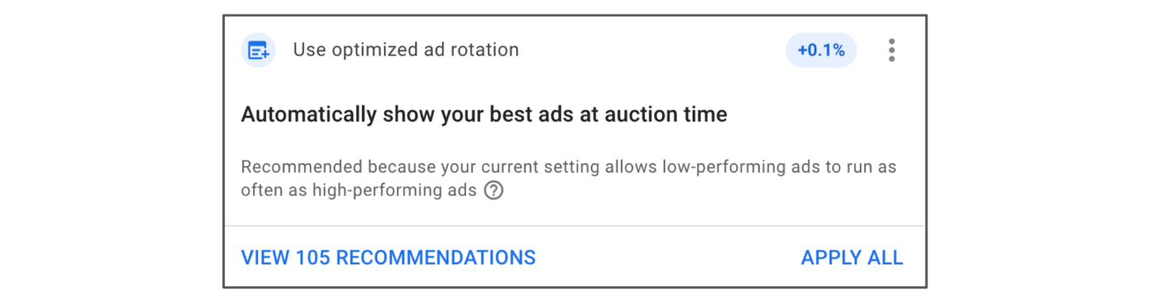

**Plan to apply**

Many recommendations will make sense for your campaign, but you might not feel comfortable applying them without testing them first. These are recommendations you can plan to apply later. For example, if your account isn’t using a Target CPA bid strategy yet, but you know you want to move to it, you’ll want to make sure conversion tracking is set up properly before you apply this recommendation. You might choose to*gradually*roll out a Target CPA bid strategy instead of applying it to the entire account right away.

**Dismiss**

Sometimes recommendations will populate that you just aren’t ready to implement. For example, if you’re using Target CPA and set a value tied to your conversions, you may see a recommendation to use Target ROAS instead. However, if the value tied to your conversions is  being checked for accuracy, you won’t want to move to Target ROAS right away. You would prefer to wait until the accuracy of the number of conversions is confirmed. These types of recommendations can be dismissed. Sometimes recommendations are simply not applicable to your account. It’s a good idea to review and dismiss these recommendations because Google Ads continuously learns what kinds of recommendations are best suited for your account. Each recommendation you dismiss helps to improve future recommendations.

**Effect of recommendations on optimization score**

If you plan to eventually apply a recommendation, don’t dismiss the recommendation just so you can keep your optimization score at a certain level. The optimization score associated with your account isn’t a precise measure of how your account is performing. It’s an indication of how well Google thinks your account is optimized. It’s fine to see a drop in your optimization score if you plan to implement a recommendation later.

Additionally, if you don’t click the Apply button for a recommendation but take steps to apply the recommendation elsewhere, the recommendation will be considered applied and will have a positive effect on your optimization score. For example, if you implement sitelinks in the GoogleAds Editor as suggested by a recommendation, that recommendation will be considered as having been applied.

**Key takeaways**

Google Ads recommendations rely on historical data to help predict if your ads will perform well. They are suggestions to help improve campaign performance and keep a campaign fresh and relevant. Examples are suggesting new keywords, an alternate bidding strategy, or new versions of ads. You can apply some recommendations immediately, but many recommendations require additional planning before you implement them. It’s best to review recommendations and decide which recommendations you will apply immediately, plan to apply later, or dismiss for the time being.

**Resources for more information**

For more information about recommendations in Google Ads, refer to the following resources:

* [Types of recommendations](https://support.google.com/google-ads/answer/3416396): Provides a more complete list of available recommendations
* [Apply or dismiss recommendations](https://support.google.com/google-ads/answer/10169817): Describes how to apply or dismiss a recommendation and track performance

**Completed**